PRACTICAL NO- 4

AIM- Perform hypothesis testing to conduct a one-sample t-test and a two-sample (independent) t-test using Python, and interpret the results.
BRIEFING OF THE AIM:
Hypothesis testing gives us a way to decide whether observed data are consistent with a claim (the null hypothesis, $H_{0}$) or whether the data provide evidence for an alternative claim (the alternative hypothesis, $H_{a}$).
- One-sample t-test: compares the sample mean to a known/population mean ($μ_{0}$). Useful when population variance is unknown and sample size is small-to-moderate.
- Two-sample (independent) t-test: compares means of two independent groups. There are two common variants:
  - Student’s t-test (assumes equal variances, equal_var=True)
  - Welch’s t-test (does not assume equal variances — safer in practice, equal_var=False)
Assumptions (for validity):
- Observations in each sample are independent.
- Data (or sampling distribution of the mean) are approximately normal — especially important for small samples.
- For the Student t-test: the two groups have equal variances. If unsure, use Welch’s t-test.
Decision rule: choose a significance level (commonly $α=0.05$). If p-value ≤ α → reject $H_{0}$; else fail to reject $H_{0}$.

LIBRARIES USED:
- numpy — numerical arrays.
- scipy.stats — ttest_1samp, ttest_ind.
- pandas (optional) — for data handling.
ONE-SAMPLE T-TEST
Problem setup (example):
A sample of 5 measurements of a physical property: [5.1, 4.9, 5.0, 5.2, 5.3]. Test if the sample mean differs from population mean $μ_{0}=5.0$at $α=0.05$.
H0: $μ=5.0$
Ha: $μ≠5.0$(two-tailed)
CODE:
import numpy as np
from scipy.stats import ttest_1samp

data = np.array([5.1, 4.9, 5.0, 5.2, 5.3])
popmean = 5.0

t_stat, p_value = ttest_1samp(data, popmean)

print("One-sample t-test")
print("------------------")
print(f"Sample mean = {data.mean():.4f}, n = {len(data)}")
print(f"t-statistic = {t_stat:.4f}")
print(f"p-value = {p_value:.4f}")

OUTPUT:
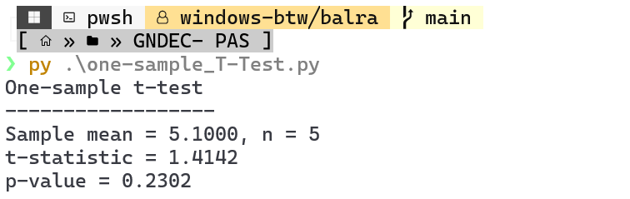
INTERPRETATION:
p = 0.2302 > 0.05 → fail to reject $H_{0}$. There is no significant evidence that the mean differs from 5.0 at the 5% level.
TWO-SAMPLE (INDEPENDENT) T-TEST
Problem setup (example):
Group A: [5.1, 4.9, 5.0, 5.2, 5.3]
Group B: [4.7, 4.8, 4.9, 5.0, 4.6]
Test if the means are different at $α=0.05$.
H0: $μ_{A}=μ_{B}$
Ha: $μ_{A}≠μ_{B}$(two-tailed)
CODE:
import numpy as np
from scipy.stats import ttest_ind

g1 = np.array([5.1, 4.9, 5.0, 5.2, 5.3])
g2 = np.array([4.7, 4.8, 4.9, 5.0, 4.6])

t_stat_welch, p_value_welch = ttest_ind(g1, g2, equal_var=False) # Welch's
t_stat_student, p_value_student = ttest_ind(g1, g2, equal_var=True) # Student's

print("Two-sample t-test (Welch's)")
print("---------------------------")
print(f"Group1 mean = {g1.mean():.4f}, n1 = {len(g1)}")
print(f"Group2 mean = {g2.mean():.4f}, n2 = {len(g2)}")
print(f"Welch t-statistic = {t_stat_welch:.4f}")
print(f"Welch p-value = {p_value_welch:.4f}")

OUTPUT:
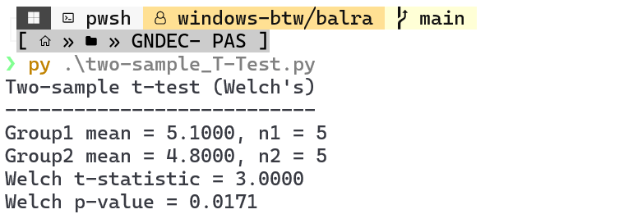
INTERPRETATION:
p = 0.0171 < 0.05 → reject $H_{0}$. There is significant evidence that the group means differ (Group A mean ≈ 5.10 vs Group B mean ≈ 4.80) at the 5% level.

